# LAMPIRAN

**Lampiran 1 Tabel Rekapitulasi Hasil Pemeriksaan Kerokan Kulit Anak**

|  |  |  |  |  |
| --- | --- | --- | --- | --- |
| **No.** | **Jenis Kelamin** | **Usia** | **Hasil Pemeriksaan KOH 10% + Tinta Parker Blue Black** | **Hasil Pemeriksaan KOH 10% + Methylene Blue** |
| 1. | Laki-laki | 12 tahun | Positif | Negatif |
| 2. | Perempuan | 10 tahun | Positif | Negatif |
| 3. | Perempuan | 9 tahun | Negatif | Negatif |
| 4. | Laki-laki | 10 tahun | Positif | Negatif |
| 5. | Laki-laki | 9 tahun | Positif | Negatif |
| 6. | Laki-laki | 9 tahun | Positif | Negatif |
| 7. | Laki-laki | 9 tahun | Positif | Positif |
| 8. | Laki-laki | 8 tahun | Positif | Negatif |
| 9. | Laki-laki | 9 tahun | Negatif | Negatif |
| 10. | perempuan | 12 tahun | Positif | Negatif |
| 11. | Laki-laki | 12 tahun | Negatif | Negatif |
| 12. | Laki-laki | 11 tahun | Negatif | Negatif |
| 13. | Laki-laki | 11 tahun | Positif | Negatif |
| 14. | Laki-laki | 11 tahun | Negatif | Negatif |
| 15. | Laki-laki | 11 tahun | Positif | Negatif |
| 16. | Laki-laki | 11 tahun | Positif | Negatif |
| 17. | Laki-laki | 11 tahun | Positif | Negatif |
| 18. | Laki-laki | 11 tahun | Positif | Negatif |
| 19. | Laki-laki | 12 tahun | Negatif | Negatif |
| 20. | Laki-laki | 10 tahun | negatif | Negatif |
| 21. | Laki-laki | 10 tahun | Negatif | Negatif |
| 22. | Laki-laki | 10 tahun | Negatif | Negatif |
| 23. | perempuan | 12 tahun | Negatif | Negatif |

**Lampiran 2 Lembar *Informed Consent***

***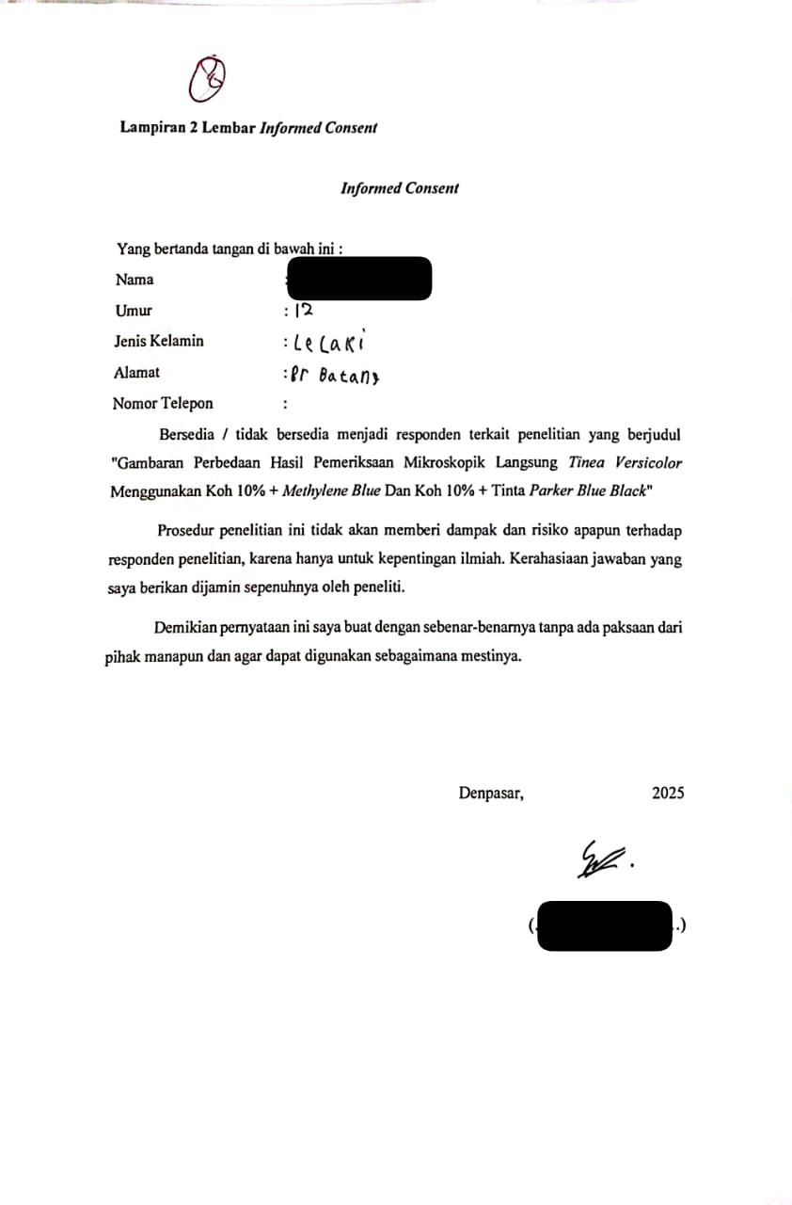***

**Lampiran 3 Cara Pengambilan Sampel Kerokan Kulit**

**CARA PENGAMBILAN SAMPEL KEROKAN KULIT:**

1. Tangan dicuci hingga bersih kemudian gunakan sarung tangan.
2. Disiapkan wadah dan alat untuk pengambilan sampel.
3. Diberikan pengarahan mengenai apa yang akan dilakukan.
4. Bersihkan area kulit dengan alcohol swab/kapas alkohol.
5. Kerok bagian yang memiliki ciri seperti bercak berwarna putih, dengan scalpel.
6. Pindahkan sampel ke slide preparat, lalu masukkan ke dalam amplop dan berikan identitas
7. Kirim sampel ke labolatorium.

**Lampiran 4 Jadwal Penelitian**

|  |  |  |  |  |  |  |  |  |  |  |  |  |  |  |  |  |  |  |  |  |  |  |
| --- | --- | --- | --- | --- | --- | --- | --- | --- | --- | --- | --- | --- | --- | --- | --- | --- | --- | --- | --- | --- | --- | --- |
| **No** | **Kegiatan** | **November** | **Desember** | | | | **Januari** | | | | **Februari** | | | **Maret** | | | | **April** | | | | |
| **3** | **1** | **2** | **3** | **4** | **1** | **2** | **3** | **4** | **1** | **2** | **3** | **1** | **2** | **3** | **4** | **1** | **2** | **3** | **4** |
| **1** | Pengajuan Judul |  |  |  |  |  |  |  |  |  |  |  |  |  |  |  |  |  |  |  |  |
| **2** | ACC Judul |  |  |  |  |  |  |  |  |  |  |  |  |  |  |  |  |  |  |  |  |
| **3** | BAB I |  |  |  |  |  |  |  |  |  |  |  |  |  |  |  |  |  |  |  |  |
| **4** | BAB II |  |  |  |  |  |  |  |  |  |  |  |  |  |  |  |  |  |  |  |  |
| **5** | BAB III |  |  |  |  |  |  |  |  |  |  |  |  |  |  |  |  |  |  |  |  |
| **6** | ACC Proposal |  |  |  |  |  |  |  |  |  |  |  |  |  |  |  |  |  |  |  |  |
| **7** | Ujian Proposal |  |  |  |  |  |  |  |  |  |  |  |  |  |  |  |  |  |  |  |  |
| **8** | Perbaikan Proposal |  |  |  |  |  |  |  |  |  |  |  |  |  |  |  |  |  |  |  |  |
| **9** | Pembuatan Surat Izin Penelitian |  |  |  |  |  |  |  |  |  |  |  |  |  |  |  |  |  |  |  |  |
| **10** | Penyebaran Informed Consent |  |  |  |  |  |  |  |  |  |  |  |  |  |  |  |  |  |  |  |  |
| **11** | Pengambilan Sampel |  |  |  |  |  |  |  |  |  |  |  |  |  |  |  |  |  |  |  |  |
| **12** | Analisis Sampel |  |  |  |  |  |  |  |  |  |  |  |  |  |  |  |  |  |  |  |  |
| **13** | Analisis Data |  |  |  |  |  |  |  |  |  |  |  |  |  |  |  |  |  |  |  |  |
| **14** | Penyusunan Karya Tulis Ilmiah |  |  |  |  |  |  |  |  |  |  |  |  |  |  |  |  |  |  |  |  |
| **15** | Sidang Karya Tulis Ilmiah |  |  |  |  |  |  |  |  |  |  |  |  |  |  |  |  |  |  |  |  |
| **16** | Revisi Karya Tulis Ilmiah |  |  |  |  |  |  |  |  |  |  |  |  |  |  |  |  |  |  |  |  |
| **17** | Pengumpulan Karya Tulis Ilmiah |  |  |  |  |  |  |  |  |  |  |  |  |  |  |  |  |  |  |  |  |

**Lampiran 5 Anggaran Penelitian**

**ANGGARAN PENELITIAN**

|  |  |  |
| --- | --- | --- |
| No. | **Pengeluaran** | **Harga** |
| **A.** | **PERSIAPAN** |
| 1. | Penggandaan proposal ( Print + fotocopy) | Rp. 200.000 |
| 2. | Konsumsi | Rp. 150.000 |
| **B.** | **PELAKSANAAN** |  |
| 1. | Amplop (30 pcs) | Rp. 30.000 |
| 2. | Pembelian Reagen KOH 10% | Rp. 60.000 |
| 3. | Cover Glass (1 box ) | Rp. 25.000 |
| 4. | Objek Glass ( 1 box ) | Rp. 60.000 |
| 5. | Kapas Alkohol ( 1 box ) | Rp. 20.000 |
| 6. | Handscoon ( 1 box ) | Rp. 65.000 |
| 7. | Scalpel (1box) | Rp. 85.000 |
| 8. | Tinta parker blue black | Rp. 150.000 |
| 9. | Methylene Blue | Rp. 100.000 |
| **C.** | **TAHAP AKHIR** |  |
| 1. | Pengandaan karya tulis ilmiah (print + fotocopy) | Rp. 250.000 |
| 2. | Biaya pengumpulan data karya tulis ilmiah | Rp. 200.000 |
|  | **TOTAL** | **Rp. 1.395.000** |

**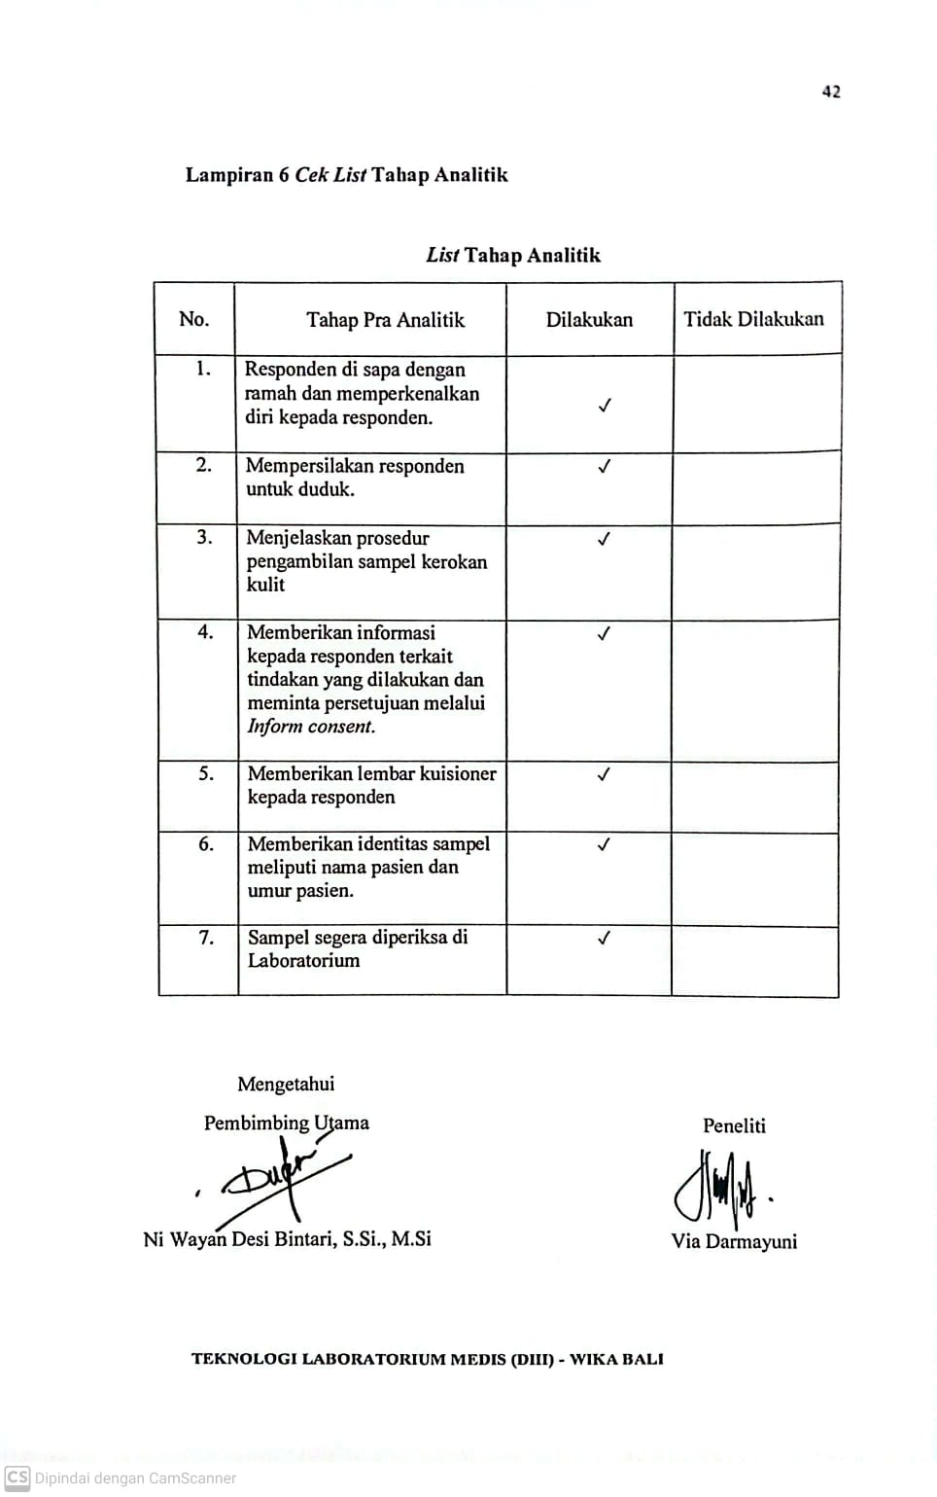**

**Lampiran 7. Surat Ijin Penelitian**

**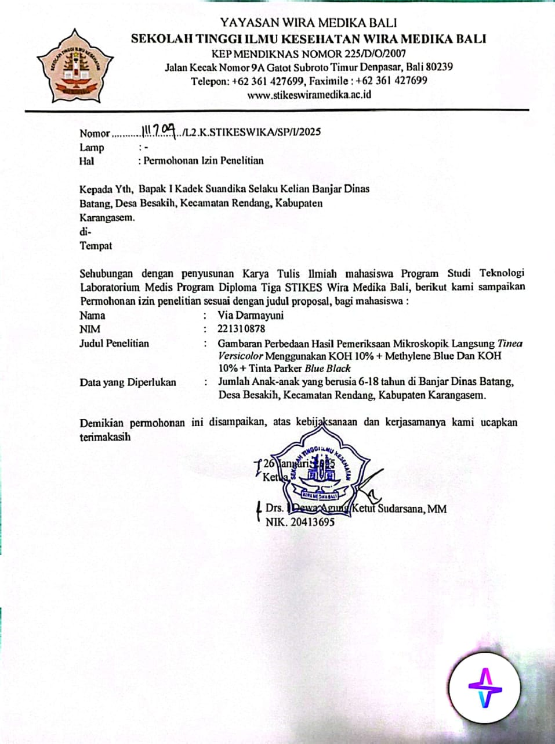**

**Lampiran 8. Hasil Uji Statistik**

* **Karakteristik responden**

|  |  |  |  |  |  |
| --- | --- | --- | --- | --- | --- |
| **jenis\_kelamin** | | | | | |
|  | | Frequency | Percent | Valid Percent | Cumulative Percent |
| Valid | perempuan | 4 | 17.4 | 17.4 | 17.4 |
| laki laki | 19 | 82.6 | 82.6 | 100.0 |
| Total | 23 | 100.0 | 100.0 |  |

* **Hasil Pemeriksaan KOH 10% + Tinta Parker Blue Black**

|  |  |  |  |  |  |
| --- | --- | --- | --- | --- | --- |
| **koh\_tinta\_parker** | | | | | |
|  | | Frequency | Percent | Valid Percent | Cumulative Percent |
| Valid | positif | 13 | 56.5 | 56.5 | 56.5 |
| negatif | 10 | 43.5 | 43.5 | 100.0 |
| Total | 23 | 100.0 | 100.0 |  |

* **Hasil Pemeriksaan KOH 10% + Methylene blue**

|  |  |  |  |  |  |
| --- | --- | --- | --- | --- | --- |
| **koh\_methylene\_blue** | | | | | |
|  | | Frequency | Percent | Valid Percent | Cumulative Percent |
| Valid | positif | 2 | 8.7 | 8.7 | 8.7 |
| negatif | 21 | 91.3 | 91.3 | 100.0 |
| Total | 23 | 100.0 | 100.0 |  |

* **Hasil Uji Chi Square Test**

|  |  |  |  |  |  |
| --- | --- | --- | --- | --- | --- |
| **Chi-Square Tests** | | | | | |
|  | Value | df | Asymptotic Significance (2-sided) | Exact Sig. (2-sided) | Exact Sig. (1-sided) |
| Pearson Chi-Square | 10.268a | 1 | .001 |  |  |
| Continuity Correctionb | 8.317 | 1 | .004 |  |  |
| Likelihood Ratio | 11.103 | 1 | .001 |  |  |
| Fisher's Exact Test |  |  |  | .003 | .002 |
| Linear-by-Linear Association | 10.045 | 1 | .002 |  |  |
| N of Valid Cases | 46 |  |  |  |  |
| a. 0 cells (0.0%) have expected count less than 5. The minimum expected count is 7.00. | | | | | |
| b. Computed only for a 2x2 table | | | | | |

**Lampiran 9. Dokumentasi Penelitian**

|  |  |  |
| --- | --- | --- |
| **No.** | **Dokumentasi** | **Keterangan** |
| **1** | **C:\Users\prans\AppData\Local\Packages\5319275A.WhatsAppDesktop_cv1g1gvanyjgm\TempState\D4A897919A124958E699170B2B1DC8F2\Gambar WhatsApp 2025-05-20 pukul 11.16.51_370f719e.jpg** | Alat dan bahan penelitian |
| **2** | **C:\Users\prans\AppData\Local\Packages\5319275A.WhatsAppDesktop_cv1g1gvanyjgm\TempState\9E6A921FBC428B5638B3986E365D4F21\Gambar WhatsApp 2025-05-20 pukul 11.18.01_b5e31541.jpg** | Pengambilan sampel kerokan kulit |
| **3** | **C:\Users\prans\AppData\Local\Packages\5319275A.WhatsAppDesktop_cv1g1gvanyjgm\TempState\8B313CBF30999888DE32DA1EC83FF503\Gambar WhatsApp 2025-05-20 pukul 11.34.53_d5da5b18.jpg** | Sampel kerokan kulit |
| **4** | **C:\Users\prans\AppData\Local\Packages\5319275A.WhatsAppDesktop_cv1g1gvanyjgm\TempState\E9FB2EDA3D9C55A0D89C98D6C54B5B3E\Gambar WhatsApp 2025-05-20 pukul 11.17.33_be7a3397.jpg** | Pengamatan mikroskopis |
| **5** | **C:\Users\prans\AppData\Local\Packages\5319275A.WhatsAppDesktop_cv1g1gvanyjgm\TempState\097E26B2FFB0339458B55DA17425A71F\Gambar WhatsApp 2025-05-20 pukul 11.43.21_c164e5da.jpg** | Hasil positif mikroskopis menggunakan KOH 10% + Tinta Parker *blue black* |
| **6** | **C:\Users\prans\AppData\Local\Packages\5319275A.WhatsAppDesktop_cv1g1gvanyjgm\TempState\A2D10D355CDEBC879E4FC6ECC6F63DD7\Gambar WhatsApp 2025-05-20 pukul 11.44.08_353e7196.jpg** | Hasil positif mikroskopis KOH 10% + methylene *blue* |