LAMPIRAN
Lampiran 1 Jadwal Penelitian

No | Kegiatan | Januari 2026 |  |  |  | Februari 2026 |  |  |  | Maret 2026 |  |  |  | April 2026 |  |  |  | Mei 2026 |  |  |  | Juni  2026
No | Kegiatan | 1 | 2 | 3 | 4 | 1 | 2 | 3 | 4 | 1 | 2 | 3 | 4 | 1 | 2 | 3 | 4 | 1 | 2 | 3 | 4 | 1 | 2 | 3 | 4
1 | ACC Judul
2 | BAB I
3 | BAB II
4 | BAB III
5 | ACC Proposal
6 | Ujian Proposal
7 | Perbaikan Proposal
8 | Pembuatan Surat Izin Penelitian
9 | Pengumpulan Data
10 | Analisis Sampel
11 | Analisis Data
12 | Penyusunan Skripsi
13 | Sidang Skripsi
14 | Revisi Skripsi
15 | Pengumpulan Skripsi

Lampiran 2 Anggaran Penelitian

No | Uraian | Volume | Harga Satuan (Rp) | Total (Rp)
1 | Penggandaan proposal | 4 eksemplar | 50.000 | 200.000
2 | Handscoon | 1 box | 40.000 | 40.000
3 | Tabung | 1 box | 150.000 | 150.000
4 | Alkohol swab | 1 box | 50.000 | 50.000
5 | Strip HB dan HCT | 1 box | 150.000 | 150.000
6 | Biaya Etik Penelitian | 1 eksemplar | 250.000 | 250.000
7 | Penggandaan Skripsi | 4 eksemplar | 75.000 | 300.000
8 | Publikasi | 1 manuskrip | 300.000 | 300.000
Total Biaya |  |  |  | 1.440.000

Lampiran 3 Ethical Clearance
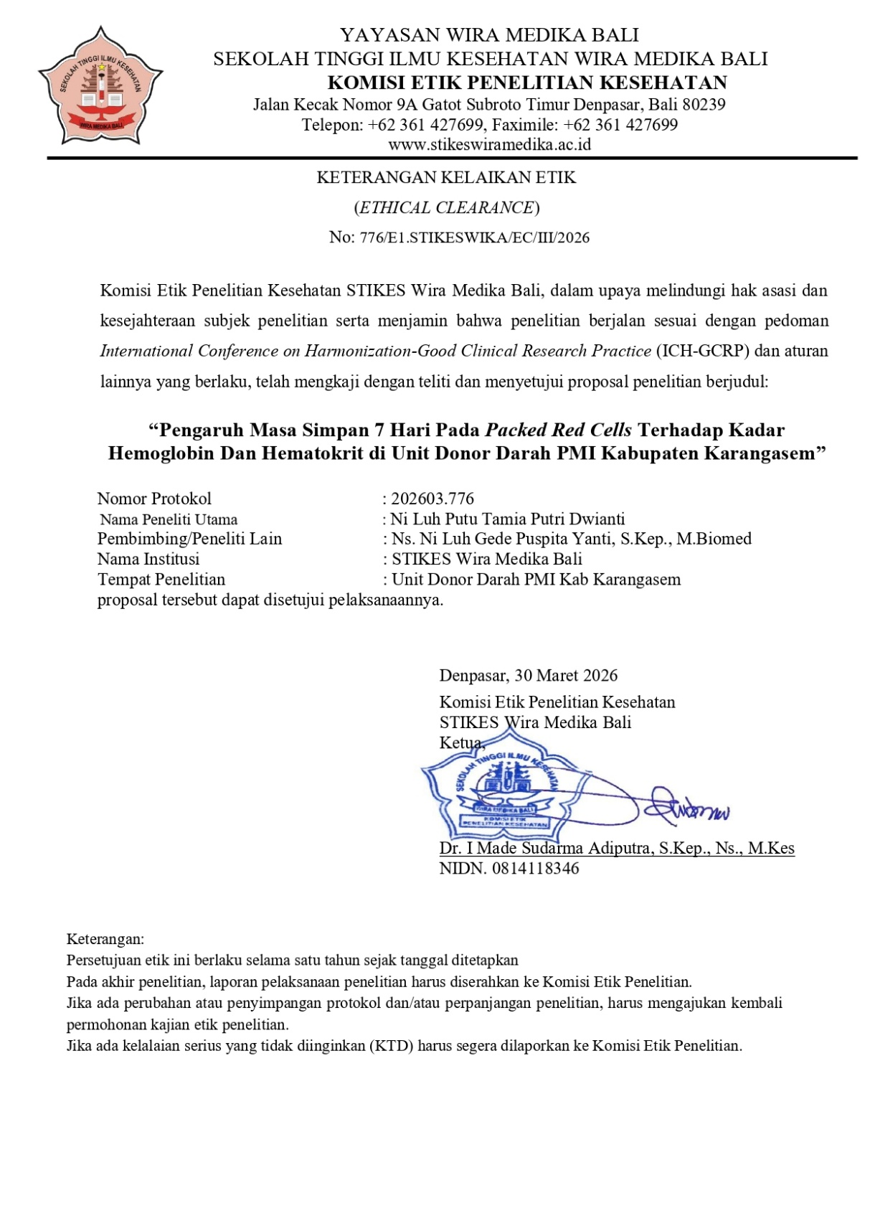

Lampiran 4 Surat Ijin Penelitian

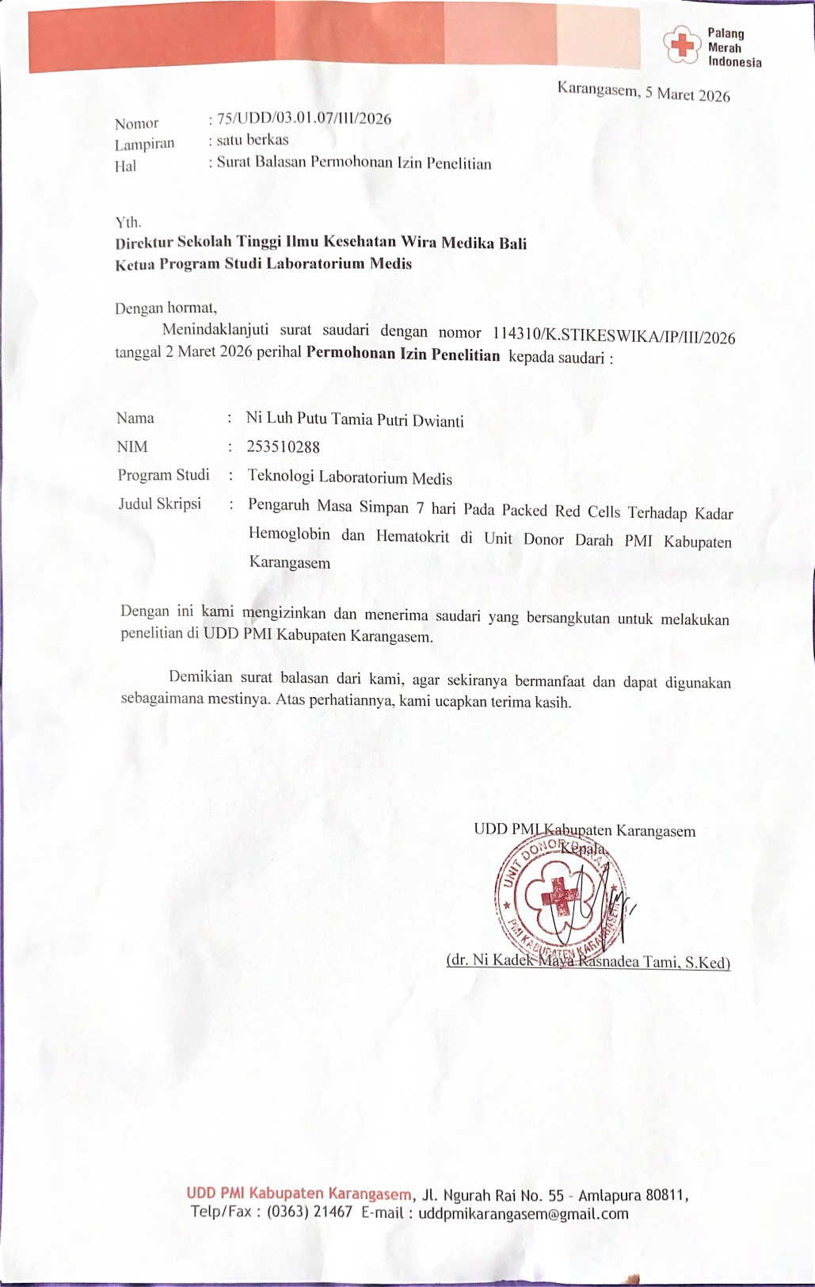

Lampiran 5 Data Rata Rata Penerimaan Darah Perbulan

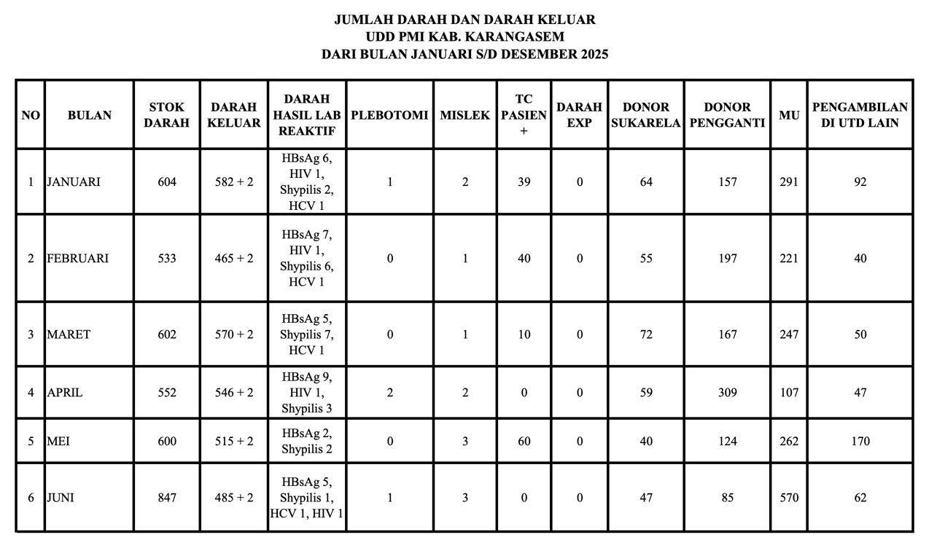
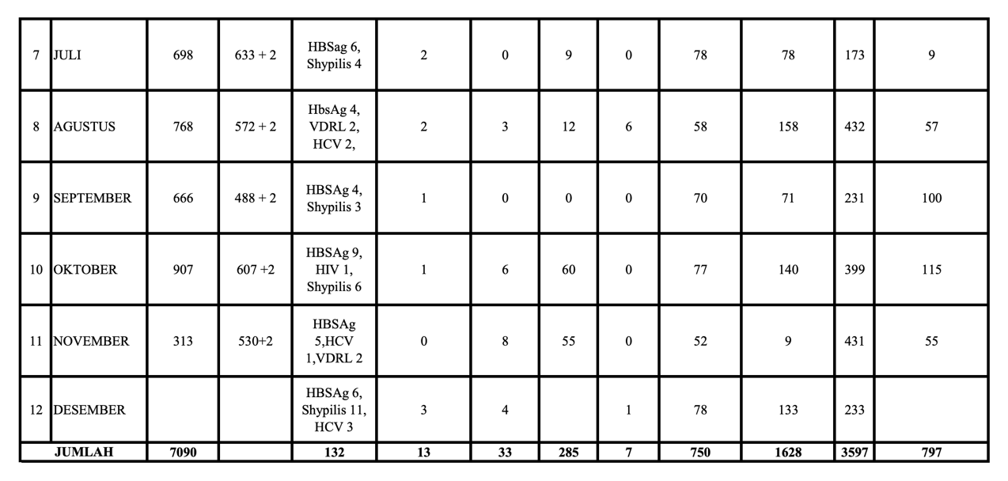

Lampiran 6 Quality Control

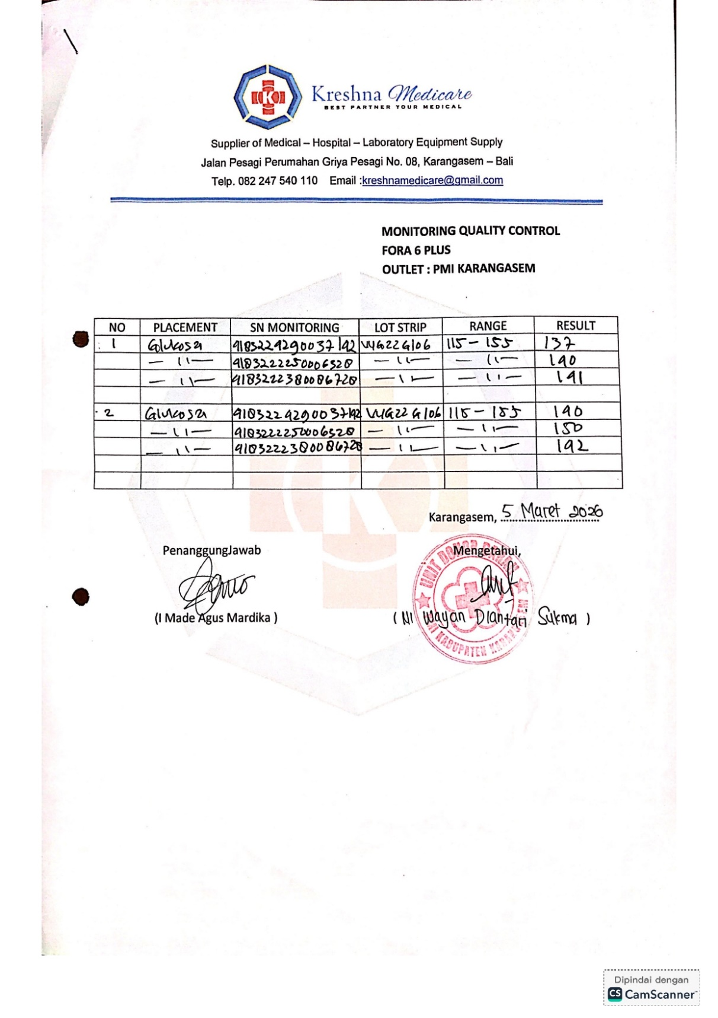

Lampiran 7 Lembar Pengumpulan Data

No | Kode Sampel | Kadar HB |  | Kadar HCT |  | Keterangan
No | Kode Sampel | Masa Simpan 0 hari  g/dL | Masa Simpan 7 hari  g/dL dL | Masa Simpan 0 hari  g/dL | Masa Simpan 7 hari  g/dL | Keterangan
1 | 1024 | 18,70 | 12,50 | 55,00 | 37,00
2 | 1025 | 17,70 | 12,50 | 61,00 | 37,00
3 | 1026 | 16,60 | 13,40 | 49,00 | 41,00
4 | 1027 | 13,60 | 11,10 | 40,00 | 35,00
5 | 1028 | 12,50 | 10,50 | 37,00 | 30,00
6 | 1029 | 15,60 | 12,50 | 46,00 | 37,00
7 | 1030 | 12,50 | 10,70 | 37,00 | 32,00
8 | 1031 | 18,00 | 12,50 | 53,00 | 37,00
9 | 1032 | 14,30 | 11,80 | 39,00 | 35,00
10 | 1033 | 14,60 | 10,00 | 43,00 | 31,00
11 | 1034 | 13,60 | 8,10 | 40,00 | 24,00
12 | 1035 | 15,30 | 10,80 | 45,00 | 32,00
13 | 1036 | 16,60 | 11,50 | 49,00 | 34,00
14 | 1037 | 15,60 | 18,00 | 46,00 | 53,00
15 | 1038 | 13,60 | 17,30 | 40,00 | 51,00
16 | 1039 | 15,90 | 11,90 | 47,00 | 35,00
17 | 1040 | 13,90 | 9,80 | 41,00 | 30,00
18 | 1041 | 17,00 | 13,60 | 50,00 | 40,00
19 | 1042 | 15,60 | 11,50 | 46,00 | 34,00
20 | 1043 | 13,90 | 11,90 | 41,00 | 35,00
21 | 1044 | 15,60 | 18,00 | 46,00 | 53,00
22 | 1045 | 13,90 | 9,80 | 41,00 | 30,00
23 | 1046 | 15,90 | 11,90 | 47,00 | 35,00
24 | 1047 | 13,60 | 17,30 | 40,00 | 51,00
25 | 1048 | 14,30 | 11,80 | 39,00 | 35,00
26 | 1049 | 14,60 | 10,00 | 43,00 | 31,00
27 | 1050 | 15,90 | 11,90 | 47,00 | 35,00
28 | 1051 | 18,00 | 12,50 | 53,00 | 37,00
29 | 1052 | 14,60 | 10,00 | 43,00 | 31,00
30 | 1053 | 13,60 | 8,10 | 40,00 | 24,00

Lampiran 8 Analisis Data
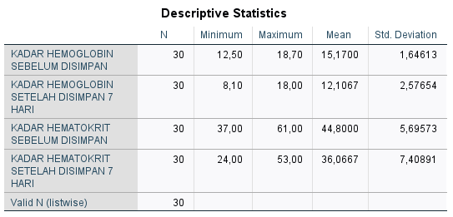

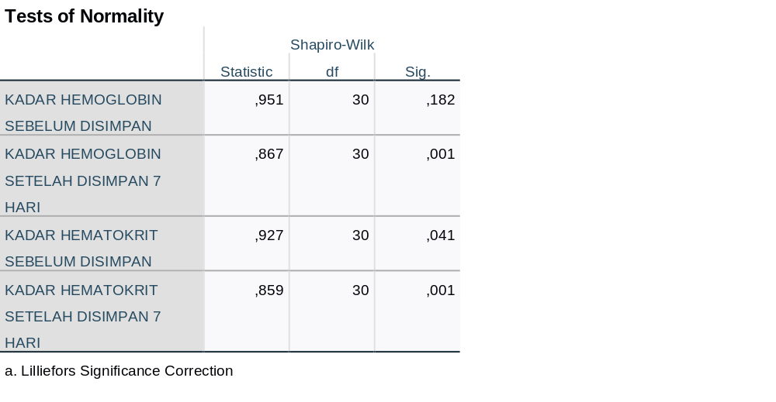
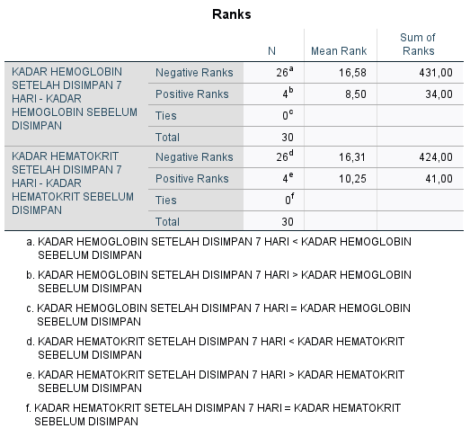

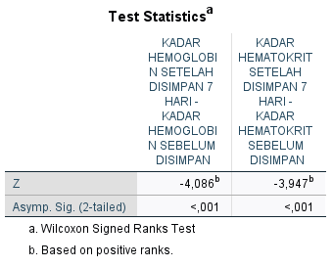

Lampiran 9 Dokumentasi Penelitian
Dokumentasi Penelitian
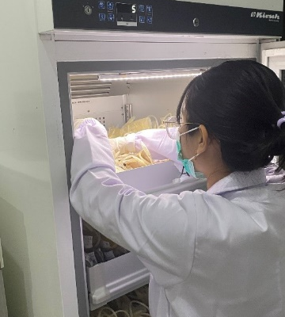 | 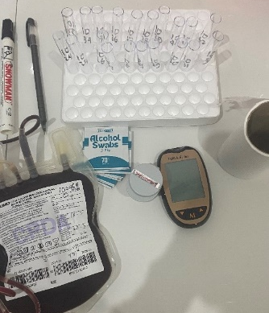 | 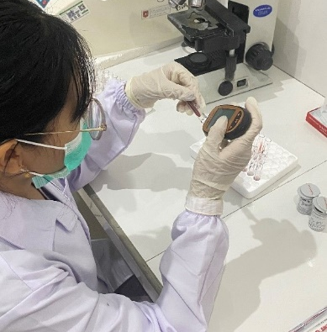
Pengambilan sampel dilemari penyimpanan | Persiapan alat dan bahan | Pemeriksaan kadar Hb dan Hct sebelum penyimpanan
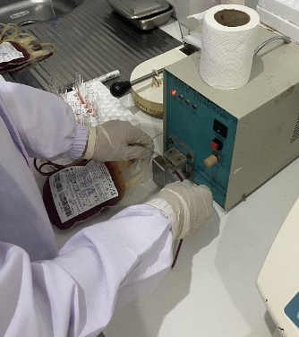 | 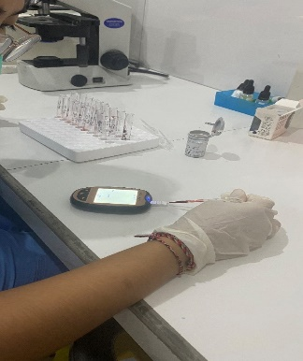 | 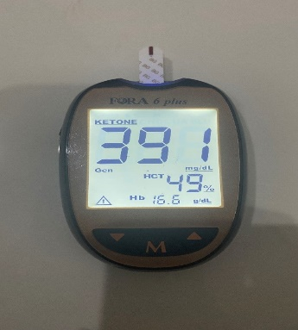
Proses penyegelan selang kantong darah PRC | Pemeriksaan kadar Hb dan Hct sesudah penyimpanan 7 hari | Hasil kadar Hb dan Hct sesudah penyimpanan 7 hari
 | 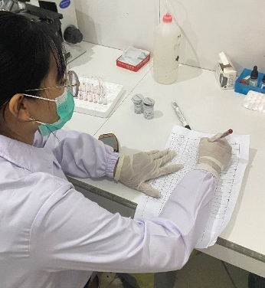
 | Pencatatan hasil

